Basic Shell Scripting : Create a directory for scripts mkdir /sami/scripts
vi helloworld
#!/bin/bash
#basic script
Echo “helloworld”

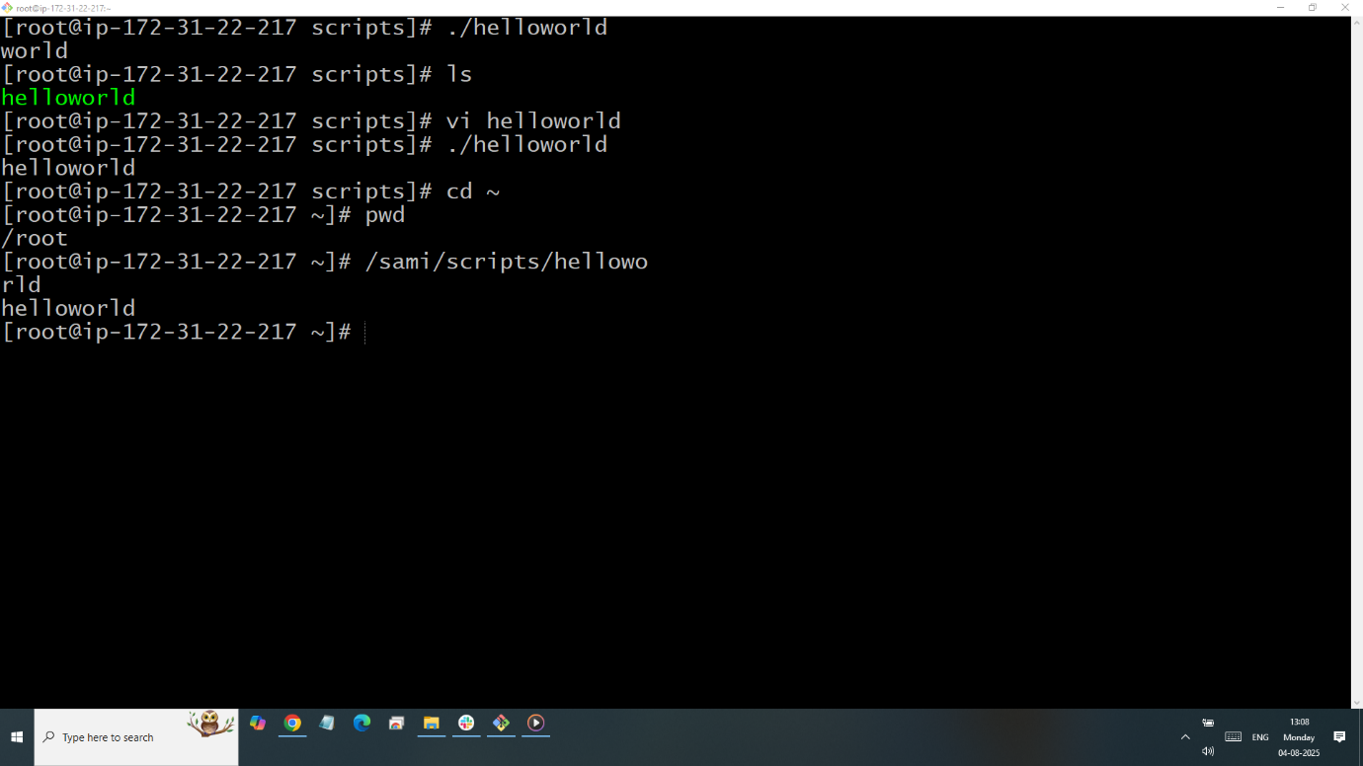

Defining Task
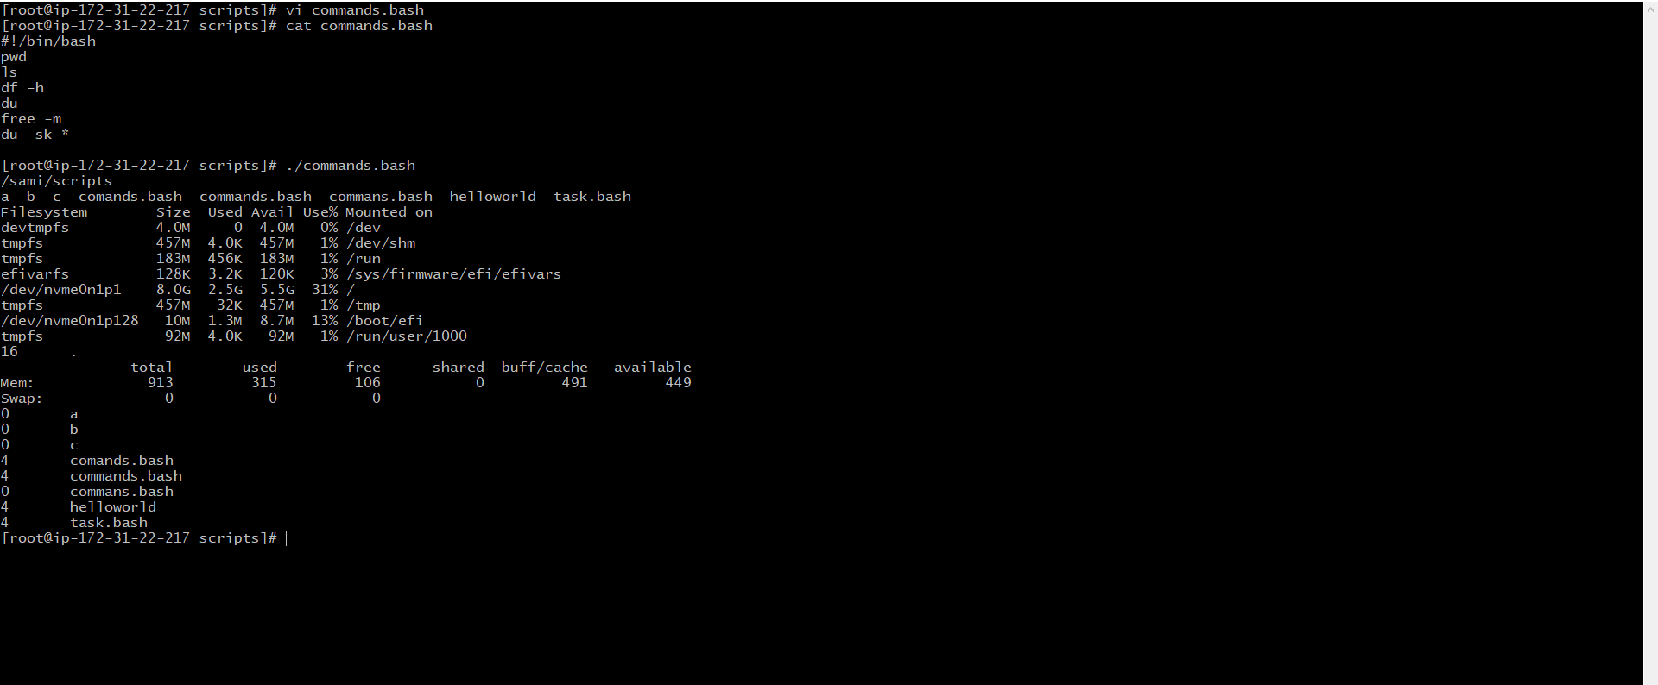

Define Variables
#!/bin/bash

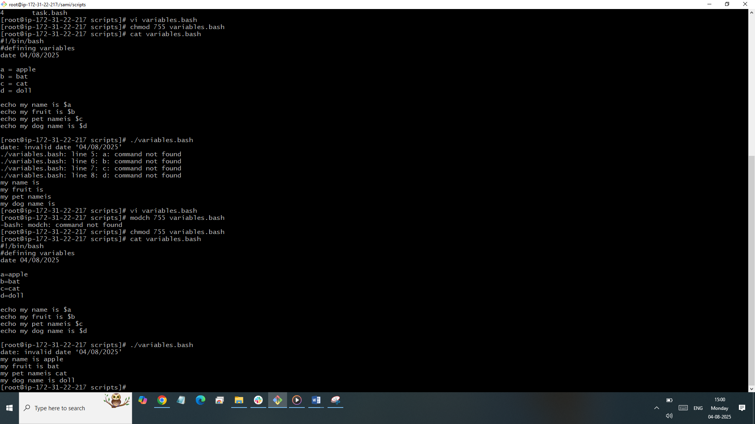
Read Input
#!/bin/bash
# Read user input
echo "What is your first name?"
read sami
echo (echo will read the ouput)
echo "What is your last name?"
Mohammad
echo

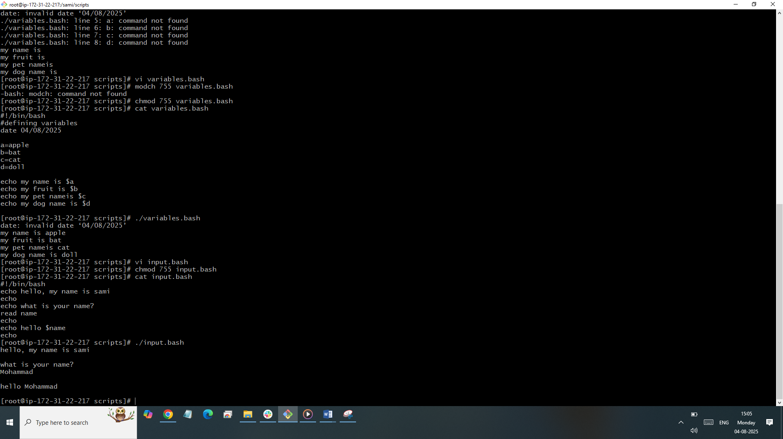

Ouput
Always make sure our variables inside echo then we need to use tick marks
